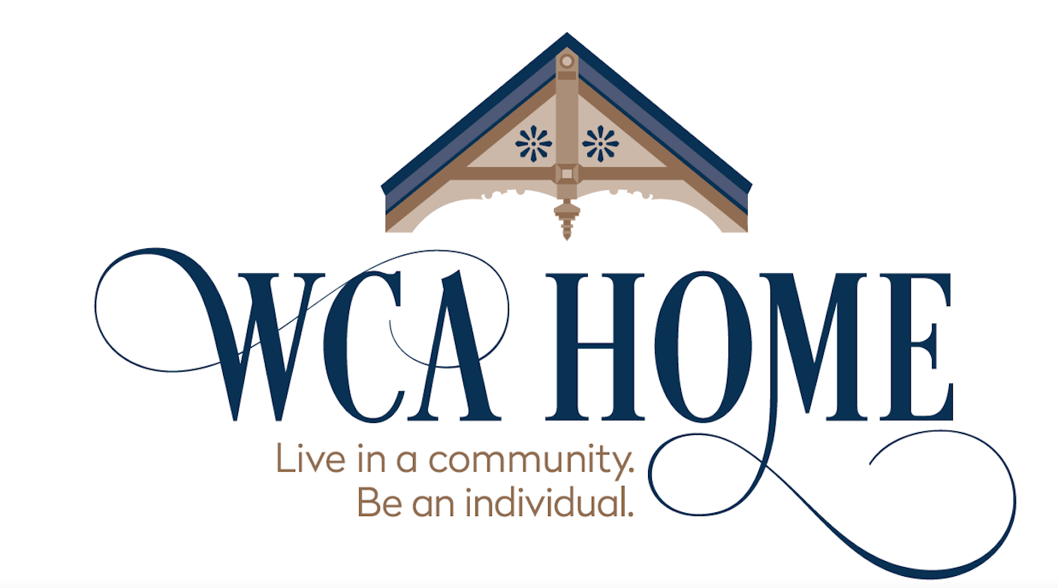

For immediate release: January 2, 2023
Contact: Leave message or text at 716-969-6027 for asap callback from Christine Davis Mantai.

The Women’s Christian Association of Fredonia announced it is closing the adult home and assisted living facility it has operated since 1892. “Financial losses make it impossible to continue,” Christine Davis Mantai, board president, said. The WCA Home employs 22 people, has 17 residents and has rooms for 42. The NYS Department of Health has approved the plan for closing and noted the WCA’s licenses to operate will expire in February and March.

Residents, family members, and employees were notified at special meetings held with the board of directors today. “The decision to close after more than a century of excellent care in the center of the village is heartbreaking to every board member,” Ms. Mantai said. “For the past year, the board of directors has been looking for a larger, non-profit corporation to keep the home operating, but we have not been successful,” Ms. Mantai said.

The last time the home operated “in the black” was 2019. The WCA Home has been covering major losses of roughly $65,000 per month by tapping its investment fund, which was built from an estate gift from the late Carol Card Dudley of Fredonia, a WCA Home benefactor. The fund, key to the home’s survival since 2005, is being depleted quickly.

The not-for-profit’s board of directors will stay active until the state Attorney General approves the disposition of all assets, including the property and any remaining investment funds, as required by law. The WCA has no debts. Employees who stay on as needed will receive a retention bonus. Staff and administrators will be helping residents and their families in finding and moving to other facilities.

Other WCA board members are Vice President Lori Poniatowski, Secretary Cindy Coon, Raymond Campbell, Marjorie Plaister, and Susan Sosinski. One board seat is open to the public. Assistance in the closure is also coming from the NYS Department of Health, the Attorney General, and the Empire State Association for Assisted Living.

The home was founded in the 19th century by a committee of local women who bought the Mary Putnam family home at 134 Temple Street as a distinctive residence for aging women. They filed a charter through New York State as a non-profit entity after forming a chapter of the Women’s Christian Association to run the home. Over its century-plus lifespan, the home was expanded several times, and the community kept the founders’ vision by continuing the association and operating the home to the present. Donations from citizens, businesses, and churches have been essential to its survival since the 1890s. In 2012, it obtained a special license as an approved provider of NY State’s Assisted Living Program. This allowed its residents to age in place and receive additional care and services, while postponing the need to move to a facility with 24-hour skilled nursing care. It is the only adult home in Northern Chautauqua County licensed for the ALP program.
###

